📈 Website Traffic and Engagement Analysis

**Date:** July 3, 2025

**Author:** Pritidarshini Biswal

**🔍 Objective**

Analyze website user traffic, engagement, and channel-wise performance using hourly data from analytics tools (e.g., Google Analytics 4). This report answers key business questions to help optimize user acquisition and content strategy.

**📁 Dataset Description**

|  |  |
| --- | --- |
| Column Name | Description |
| Session primary channel group | Traffic source (e.g., Direct, Organic Social) |
| Date + hour (YYYYMMDDHH) | Timestamp of traffic in hourly granularity |
| Users | Unique users in that hour |
| Sessions | Total sessions started |
| Engaged sessions | Meaningful sessions (time spent, clicks etc.) |
| Average engagement time per session | Time (in seconds) spent actively in each session |
| Engaged sessions per user | Engaged sessions per unique user |
| Events per session | Interactions per session |
| Engagement rate | % of sessions that were engaged |
| Event count | Total number of events triggered |

**1️⃣ What patterns or trends can you observe in website sessions and users over time?**

✅ Conclusion:

Analysis of the time-series data reveals clear and actionable patterns in website traffic:  
  
• Peak Traffic Windows:  
 - The highest user activity occurs between 3 PM – 8 PM and 12 AM – 3 AM.  
 - These hours show consistent spikes in both sessions and users.  
  
• Consistent Alignment:  
 - Trends for sessions and users are highly correlated.  
 - Suggests stable behavior and one session per visit on average.  
  
• Low Activity Periods:  
 - Early morning (6 AM – 11 AM) shows low traffic.  
  
📌 Business Implication:  
 - Schedule content/ad campaigns during peak windows.  
 - Use low-traffic times for updates or testing.

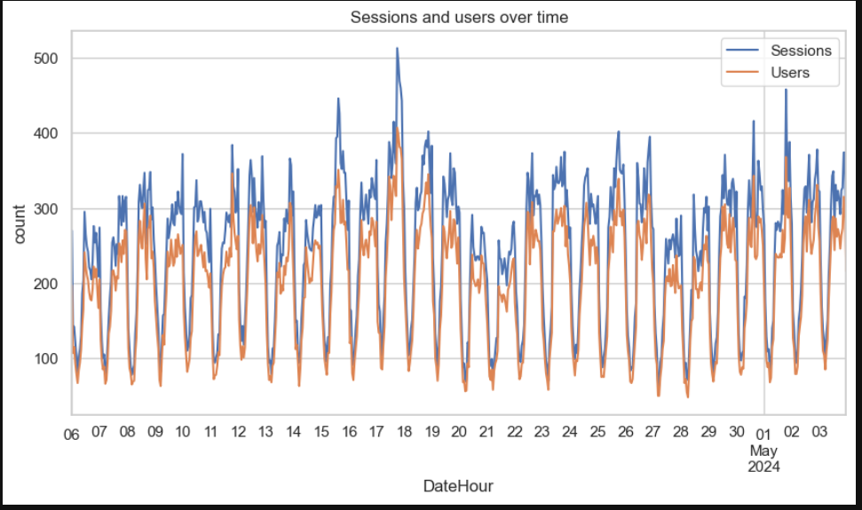

**2️⃣ Which marketing channel brought the highest number of users to the website?**

📊 Insight:

• Organic Social is the top contributor (~47,000 users).  
• Others include:  
 - Direct: ~30,000  
 - Organic Search: ~28,000  
 - Referral: ~26,000  
• Email, Organic Video, Unassigned show negligible traffic.  
💡 Action:  
 - Strengthen underperforming channels.  
 - Analyze what works in Organic Social for replication.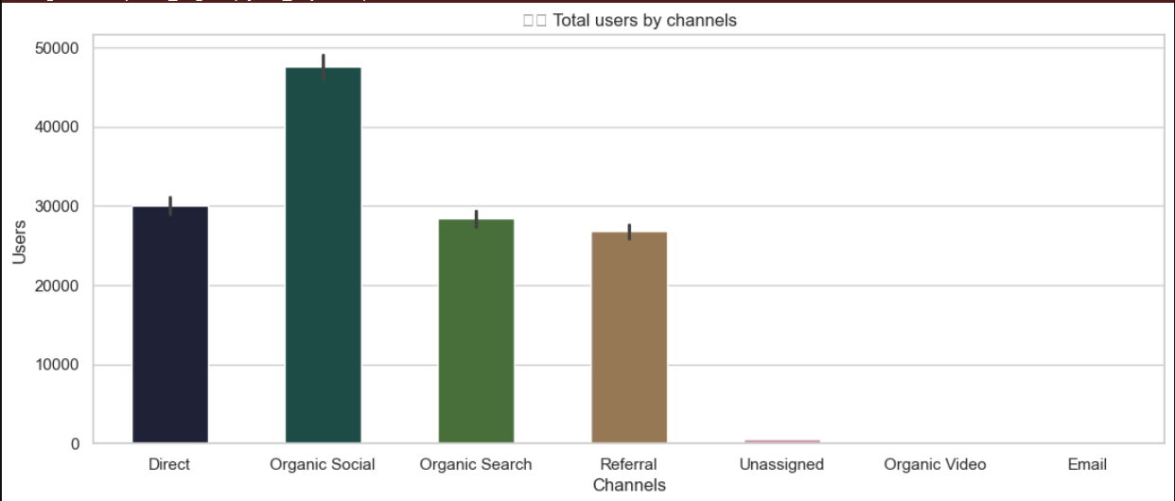

**3️⃣ Which channel has the highest average engagement time?**

⏱️ Insight:

• Organic Video: ~175 seconds/session (most engaging)  
• Followed by:  
 - Referral: ~90s  
 - Unassigned: ~75s  
 - Email: ~70s  
 - Organic Social: ~60s  
 - Organic Search: ~47s  
 - Direct: ~45s  
  
📌 Interpretation:  
 - Video content retains users longer.  
 - Focus on enhancing multimedia strategy.

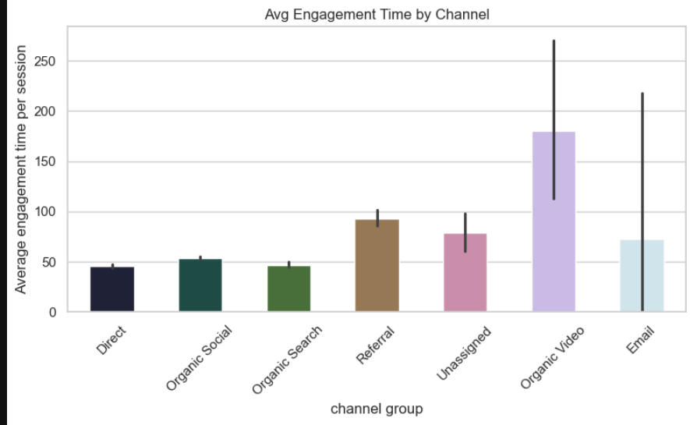  
  
**4) Engagement Rate Across Traffic Channels**

|  |  |  |
| --- | --- | --- |
| Channel | Engagement Rate Range | Notes |
| Referral | 0.60 – 0.71 | Highest engagement rate observed |
| Organic Search | 0.53 – 0.64 | Consistently strong engagement |
| Organic Social | 0.50 – 0.60 | Good engagement; driven by social reach |
| Direct | 0.40 – 0.50 | Moderate user interaction |
| Email | 0.00 – 0.50 | Wide range; variable performance |
| Unassigned | Limited data | Only two data points available |
| Organic Video | Not enough data | Single data point, no box shown |

**📌 Summary:**

* Channels with intent-based discovery (Search, Referral) show better engagement.
* Referral shows peak engagement (even above 0.8 in some cases).
* Social and Direct are moderate and can be optimized.
* Email and Video require strategic improvements due to inconsistency or low data volume.

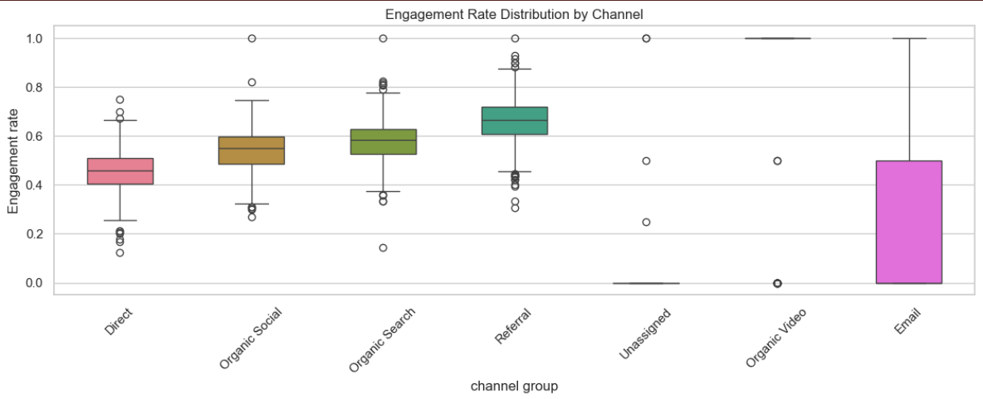

**5) Channels Driving More Engaged Sessions**

|  |  |  |  |
| --- | --- | --- | --- |
| Channel | Engaged Sessions | Non-Engaged Sessions | More Engaged? |
| Direct | 17,243 | 19,960 | ❌ No |
| Email | 1 | 2 | ❌ No |
| Organic Search | 19,425 | 13,947 | ✅ Yes |
| Organic Social | 32,697 | 27,930 | ✅ Yes |
| Organic Video | 109 | 32 | ✅ Yes |
| Referral | 20,653 | 10,337 | ✅ Yes |
| Unassigned | 4 | 555 | ❌ No |

**🔍 Insights**

**✅ High Engagement Channels:**

* **Organic Social & Referral** lead in engaged sessions.
* **Organic Search** also performs well with quality engagement.
* **Organic Video** shows deep engagement despite lower volume.

**❌ Underperforming Channels:**

* **Direct traffic**: More non-engaged users.
* **Email & Unassigned**: Very low volume and engagement.

**✅ Recommendations:**

* **Boost Video Content**: Especially where organic video performs well.
* **Improve Direct Experience**: Homepage, CTAs, UX optimizations.
* **Email Campaigns**: Personalization and better visual design.
* **Analyze Unassigned**: Improve tracking and tagging.

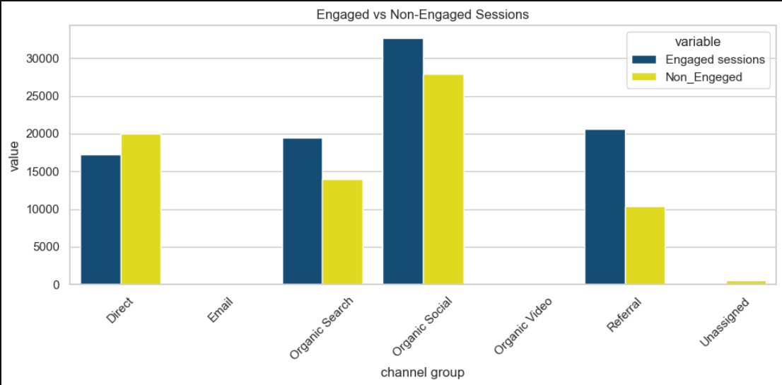

**6) Traffic by Hour and Channel**

**🔥 Heatmap Insights: Sessions by Hour & Channel Group**

**⏰ Peak Hours:**

* **11 AM – 3 PM**: Highest engagement window.
* **Midnight (0 AM)**: Huge spike for **Organic Social** (3917 sessions).

**📊 Top Channels:**

* **Organic Social**: Strongest across nearly all hours.
* **Organic Search**: Consistent traffic throughout the day.
* **Direct**: Highest at **11 PM** (2581 sessions).

**😴 Low Activity:**

* **2 AM – 6 AM**: Very low sessions across all channels.
* **Email**: Inactive during almost all hours.

**📌 Strategy Tips:**

* Best posting window: **10 AM – 3 PM**
* Improve **Email campaign timing**
* Focus effort on **Organic Social** and **Search** for max ROI

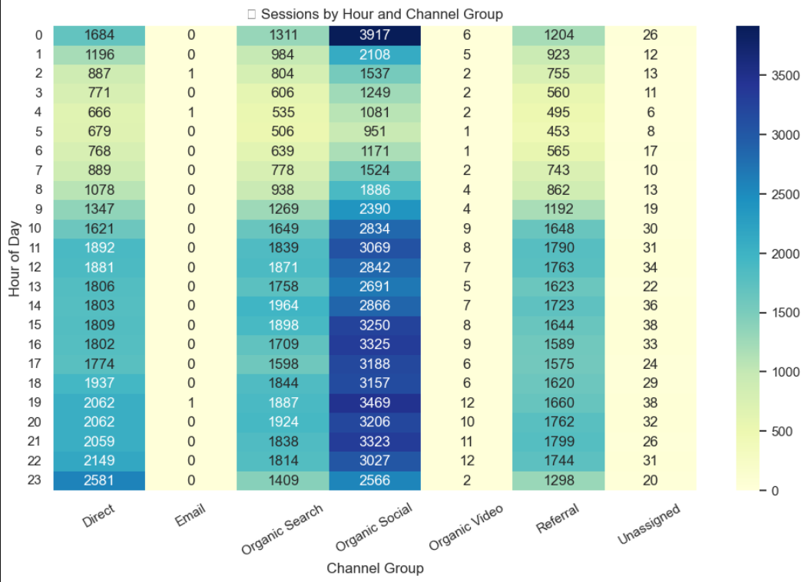

**7) Correlation: Sessions vs. Engagement Rate**

📊 Chart-Based Insight

The regression plot of **Sessions vs. Engagement Rate** shows:

**✅ Positive Correlation:**

* More sessions generally lead to better engagement.
* Regression line shows a slight upward trend.

**⚠️ High Variability at Low Sessions:**

* When sessions < 50, engagement rate is scattered between 0 and 1.
* Suggests inconsistent user behavior or niche audiences.

**↗ Stable Engagement at Higher Sessions:**

* Sessions > 100 show more concentrated engagement between 0.4 to 0.7.
* Indicates quality traffic and stable interest.

**🔥 Outliers:**

* Some unusual data points with high engagement but low sessions and vice versa.
* Could be bots, test traffic, or abandoned sessions.

